Parents,
I have gotten together a take home learning packet for your child. I have enclosed what I believe is what your child will need to complete the tasks that will be assigned. Please keep all materials together. I will be happy to answer any questions about any assignments you will have on the work sent home. You can either email me or send a message on Remind. I will do my best to get back as quickly as possible.
ELA
In the Superkids workbook please have your child do 2 pages a day – start working on pages AFTER practice page 54.
Sight Word Practice – I have sent home a list of our sight words. I would like the children to pick 2 words a day from the list (start List 8 and greater – they are great with the first 7 lists) write the word 5 times and then use it in a sentence. There is a packet of papers with an example for this activity.
Superkids Online – they should get on the website for 15 minutes a day. They should read 2 stories and then can play the games.
There are blending sounds sheets in the folder as well. They should practice these 5 minutes a day. They can practice many times.
Also, I will be assigning an assessment for superkids during the week. It will automatically pop up. They need to complete this independently.
Math
Their Word Problem packet is included in the folder. They should complete 1 word problem a day.
I have also enrolled the children on Zearn (a math website). The login information has been taped on the inside of the folder for you. This is new for them so they may need a little help getting the hang of it and I may be sending updates as to what I would like competed. Please have your child go on the website for 20 minutes a day.
I have also included extra fluency practice worksheets for them to work on as well.
Religion
I have included 2 unit packets. Unit 13 and 14. Have them look at/ talk about 1 page a day. There are activities to accompany the units as well. They can be done any time.
There is also a Stations of the Cross coloring book. I would like them to read through the booklet daily and color 1 page a day.
Writing
I have sent home some books for the children to read. These may be read with parental help. I have included some ice cream paper (with a space at the top) that I would like them to write a response to the story. The books can be read in multiple days and I would like the children to draw a picture of their favorite part and then write 2 sentences. 1 what was their favorite part and 1 about why it is their favorite part.
There is also a rainbow poem the can complete and then draw pictures of what they wrote on a separate paper.
The other lined paper (without space at the top) have your child tell me something they did each day that they enjoyed! I love to hear their stories! “Journal”
*** For Science and Social Studies, spend half the week on
Science and half the week on Social Studies ( or alternate days)*****
Social Studies
I have sent home 2 scholastic newspapers. They can be read on 1 day and be followed up by the activity sheets that accompany the newspaper.

Science
For their science activities I have included links to Mystery Science. The unit I would like them to complete is Plant and Animal Secrets. There are 6 lessons followed up by an activity. The lesson usually takes about 30 minutes. Have them listen to the lesson and if you have the materials available to do the activity please do them as well. ** Challenge – Make a leprechaun trap***
Gym
Mrs. Rusin’s Physical Education activities for students.
There are several exercise videos on the following sites to keep students active while home.
Gonoodle.com
Indoor recess
Kids bop kids - has dance along videos. Shuffle, Fight song,Best day of my life, Make some
noise and Whoop there it is
Kids Daily Exercise- kids workout 1 Beginners- Moe Jones
Art ( I attached the 1,2,3rd grade activities as well; I think these kiddos would love these as well if you want to try)
pre-K and K
Practice cutting and coloring. Good old coloring books are a gem here (or you may print pages from a free printable website). Have your child practice staying in the lines. Another alternative is to outline the black line then fill in with color.

For cutting practice, draw lines across a piece of paper. Make some straight, wavy and zig-zag. Have them cut on the line the best they can.

Another option-if supplies are available – finger painting or playing with play dough.

1, 2 and 3rd
Learn to draw sheets are attached for a more formal lesson, and only need a piece of paper. There are also a lot of free printable learn to draw pages online.
If you have the supplies, set out paints, scrap paper yarn, tape, etc... and let their imaginations run free to create a fabulous robot, machinery or fairy (to name a few!)

1, 2 and 3 sheets
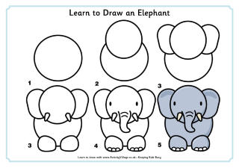
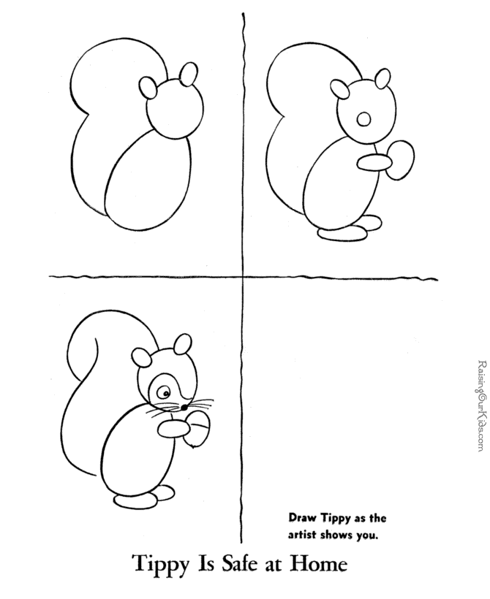

As this is the first time sending work home like this I hope this is comprehensive and explained well enough. Again, any questions please do not hesitate to contact me.
As I always tell them to please to their nicest and neatest work – NOT their fastest!!
I will miss your child dearly and hope this comes to pass as quickly as this seems to have come to fruition.
Miss Sudyn

